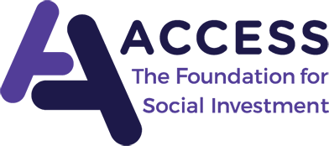
Access – The Foundation for Social Investment
Meeting of the Flexible Finance Investment Committee
2 November 2020 – 12:00 – 1:00pm
PAPER 4a – Theory of Change and Investment Policy (for decision)

The following pages contain draft versions of a simple Theory of Change for the programme, and the proposed Investment Policy.
Do the committee agree to the adoption of these documents, or are any changes required?

Draft Theory of Change

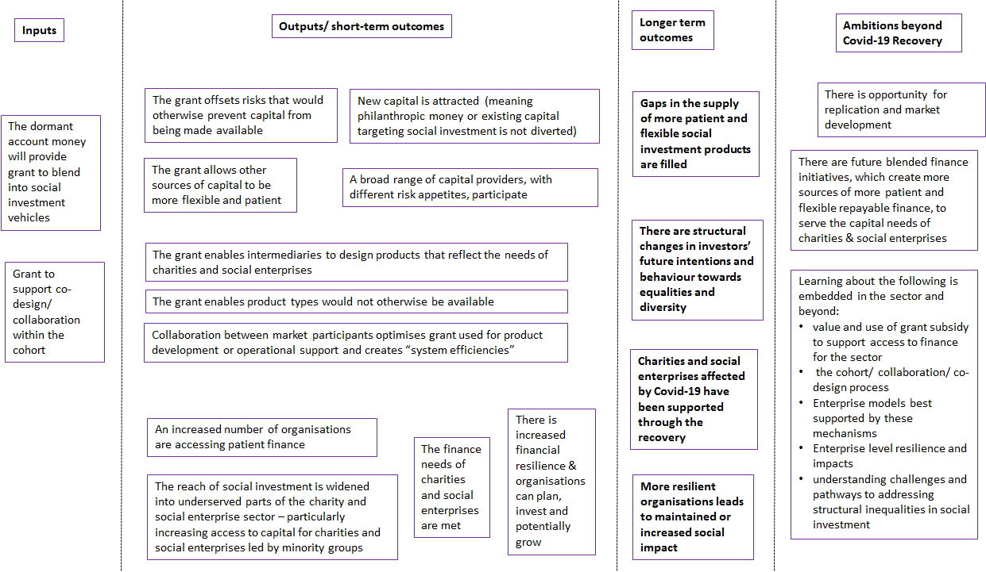
Draft Investment Policy

Introduction
In May 2020 Access received a £30m blended finance facility funded through dormant accounts. That funding has been earmarked for three purposes:
- Emergency Lending to Charities & Social enterprises, facing financial challenges due to the impacts of Covid-19 (“Emergency Lending”)
- Funding for social investors in financial difficulty due to the impacts of Covid-19
- Future blended finance initiatives, which create more sources of more patient & flexible repayable finance, to serve the capital needs of charities & social enterprises
This investment policy relates to the last of these three uses, for which Access may commit at least £21m.

Overall Investment Objective
The crisis has highlighted how vulnerable charities and social enterprises are to financial and economic shocks, and the need to find more ways to attract and provide unrestricted, flexible, long term (or even permanent) capital (“patient capital”) into the system that enables these organisations to weather a storm, adapt, invest and grow.
Currently, when patient capital is needed, VCSEs typically turn to unrestricted grants or donations; there are very limited alternatives to borrow such capital as an investment, [at speed] or at scale.
In the prevailing economic environment, where the outlook for business models and sectors is still uncertain, there is a need to develop sources of sustainable, patient capital that can be used by VCSEs in a similar way to unrestricted grants or donations to support general enterprise, long term growth objectives and financial resilience through the recovery, and attract more investment into the sector as whole. Recovery finance of this type should enable the sector to build back with much stronger foundations.
The goal is to stimulate the development of investment products that provide unrestricted, flexible, long term capital for VCSEs, that cannot be acquired elsewhere, that balance the needs of these organisations with investors acknowledging the specific features of the sector that make investment design challenging e.g. typical operating models offer low financial returns due to thin margins, the need for complex risk taking to achieve social outcomes, profit share restrictions, legal structures etc.
The grant should therefore:
- Support co-creation of patient capital products that balance investor/investee needs
- Increase the number of VCSEs with patient capital as part of plans to navigate through the recovery
- Help fill a gap in finance not currently being met
- Increase the number and range of capital providers willing to co-invest in the sector

Financial & Impact Aims
The grant will be deployed at a wholesale level in line with the following aims:
- Financial Returns for Access:
  - The investment is anticipated to be provided to intermediaries as a grant, and therefore is not expected to be repaid. It is possible that some of this grant is made on the basis that it may be repayable such as an equity investment or repayable grant; where this occurs the guiding principle will be to align incentives rather than to maximise the recycling of capital.
  - The investment from Access is expected to offset sufficient risk to leverage repayable capital from external capital sources. . This includes risks related to the longevity of the investment (e.g. operational costs of on-going oversight).It is expected that certain efficiencies can be gained at a portfolio level through collaboration or pooling of these costs/risks.
  - External capital is expected to be repaid back to investors and may generate a modest return on their investment.
- Impact on the supply of patient capital:
  - The use of grant by intermediaries should enable charities and social enterprises to access patient capital where they are not otherwise able to. This is because it will help intermediaries design suitable products that reflect the needs of those charities and social enterprises.
  - Grant should also attract external capital providers by offsetting sector and product specific risks that would otherwise prevent their capital from being made available in this way.
- Impact on borrowers:
  - Access to appropriate finance should both increase financial resilience and increase confidence to make long term decisions and to adapt to the shift in operating conditions caused by the COVID-19 pandemic.
  - The alignment of investor and borrower interests, with ongoing monitoring and wrap around support, should enable organisations to focus on long term investments and growth
- Impact on people and communities:
  - This aim of this programme is to be inclusive by design; borrowers and intermediaries will be expected to embed equality and diversity into their governance structures and to monitor/report these areas
  - This programme does not have a focus on any specific outcome areas, however the embedding of equality and diversity might provide a different way of thinking about outcomes.
  - Outcome areas will be recorded to build a better picture of the types of organisations who have required patient capital and their business models. We expect that there will emerge particular business models where patient capital lending is more likely to be a useful tool and that intermediaries will increasingly concentrate their activity in those areas.
  - The financial resilience for recipient charities & social enterprises aims to bring stability and growth (of earned income/ element being invested in) over the longer term, with the view to protect and where relevant augment the social impact of each organisation in the future

Eligibility Criteria for Investment
It is anticipated that the Investment Committee will make up to [10-12] individual investments, to use up to a maximum of £21m of Access funding. It is envisage there will be at least 2 rounds of applications, each requiring collaboration and the programme structure allowing investment propositions to be developed at different speeds. Investment proposals for round 1 are subject to the criteria outlined in this investment policy.

Collaboration areas:
It is expected that collaboration from all programme participants will be desirable to:
- Accelerate learning around the needs of charities and social enterprises for patient capital (e.g. research, open source borrower types, broker/underwriter partnerships)
- Pool expertise to devise suitable deal structures that optimise the use of subsidy in the design of end products (e.g. sharing of legal advice/deal structures, challenges)
- Promote system efficiencies particularly where grant is needed to subsidise operational support for investments (e.g. due diligence, monitoring, technical assistance)
- Determine best practice standards to embed equality and inclusion into the sourcing, assessment and award of all investments
- Collective support around fundraising for co-investment.
Though some partners will be able progress through the proposal refinement/ co-design cohort phase at an accelerated pace, all programme participants will be expected to commit to proactively engage with these areas of collaboration with the aim to optimise outcomes and achieve efficiencies at portfolio level.

At a wholesale level:
- Established Fund Managers: Investment propositions will only be accepted from those fund managers who have established investment portfolios, and have some track-record of undertaking similar types of activity to what has been proposed. This is due to the longevity of the investments and the need to minimise operational risk of the fund provider. We are actively encouraging partnerships within this programme, and new entrants could potentially join established fund managers in a partnership if this brings value, for example if providing access to eligible organisations with relevant financing needs.
- Size: We do not wish to set a minimum or maximum size of ask in terms of grant blend into an investment fund at this stage because we want to understand more about demand from fund managers. However we are not expecting to manage a large number of relationships with fund managers for this programme and so it is unlikely that we will proceed with smaller value initiatives unless there is a very clear strategic reason for doing so.

- Use of the grant in the blend: The grant can be used in a number of different ways, at a fund manager level, a fund level or at deal level.

- Given the existing levels of subsidy in that programme, this grant cannot be blended with social investment funds financed via the Growth Fund.
At a retail level:
- Product type: We imagine that in most cases the product offered by fund managers to charities and social enterprises will be long term capital (debt or equity) that provides the borrower with unrestricted funds that can be used to support general enterprise, growth or refinancing (among other activities); is unsecured; has flexible repayment features such as payment at the discretion of the borrower, interest deferral, capital write down-write up; and where the financial payments/ redemption amount of capital returned to the investor by the borrower is linked to the performance of the borrower during the investment period. It must complement existing social investment debt products.

- Deal size: We are not setting minimum and maximum deal sizes for investment made utilising the blend. However fund managers need to demonstrate the need for subsidy at all of the deal sizes they plan to make and demonstrate a robust process for assessing the need for subsidy on a case by case basis. In general the larger the deal size the higher the bar will be on the evidence they need to provide.

- Capital need: charities and social enterprises who have found that existing types of financing available to them insufficient or unsuitable and unable to support them to respond, adapt and/or grow in light of the social and economic conditions created by the COVID-19 pandemic.

- Organisation eligibility: [TBD] Standard access definitions for organisation eligibility may need to be adjusted to permit access where inflexibility results in a demonstrable unequal access to finance.

Investment Considerations
- Is the proposal inclusive and does it remove barriers for specific parts of the sector to accessing finance?
  - We would welcome some proposals that explicitly support organisations led by individuals with protected characteristics that have found it more difficult to access finance historically.
  - All funds must agree to participate to proactively engage to design best practice standards related to equality, diversity and inclusivity considerations. As a minimum, all funds must monitor the diversity of recipient organisations [women-led; disability-led; LGBTQ-led and BAME-led].; must seek diversity on their Investment Committees; must partner with representatives from the communities they are funding (if applicable).
  - There are more barriers for BAME groups to accessing finance than for other protected characteristics – this will be a particular focus for the collaborative design process.

- What is the problem being addressed and market context?
  - What insight does the applicant offer regarding charity/social enterprise need for patient capital? What do they envisage patient capital will be used for? How does patient capital fit with other financing available to these organisations?
  - Who are the “target” borrowers? Do they know them well? How do they plan to identify/reach them?
  - What methods have they used/proposed to assess, test and demonstrate demand and need for this type of product?
  - How large do they think the market is?
  - What are the biggest challenges to take-up of this product?
  - The fund manager will need to be able to demonstrate not only that it understands the nature of the demand it is trying to meet but also that it can actively reach the charities and social enterprises who can most benefit from recovery finance
  - The fund manager will need to explain how the offer which would be created here sits within the market place and how charities and social enterprises would navigate towards it.
  - Are any efficiencies included in the proposal that can benefit other market players/the system?

- What problem is the grant trying to solve? The provision of grant may look to address one or multiple barriers that capital providers, fund managers and borrowers face in accessing repayable finance for the recovery. Below are some possible examples:
Financial Risk | Where the proposed risk of default or non-payment is too high for an investment to make sense, for example where future income streams are deemed too speculative & high-risk, or long term & low return, or repayment terms are potentially complex
Borrowing cost: | Where the risks of a transaction make the borrowing costs unaffordable for an organisation to accept, for example due to tight margins in the organisation’s business model
Investment readiness: | Due to duration of the transactions, and the higher weighting on the final repayment, it is expected that investors will require more detailed due diligence. This may put more burden on both the fund manager and the borrower
Deal structures/ legal: | This programme allows for new products to be developed. Looking across to other markets, there are legal considerations regarding how this form of capital would exist alongside other forms of capital, payment features and legal form given the variety of organisational structures that exist in the sector
Operational risk: | The long nature of these transactions will require a long term relationship with the borrower (particularly with key person risk), and ongoing monitoring / reporting of investment performance. The complexity of transactions also exposes originating organisations to execution risk if deals do not go ahead

  - What specific risk or costs will the grant address?
  - How will it solve problems for the capital provider? The fund manager? The borrower?
  - How is the grant enabling supply of capital to flow from capital providers to borrowers?
  - What other risks have been identified in their proposal? How are these being addressed if not through grant subsidy?

- Details on use of grant?
  - How will the grant flow?
  - Where will it be applied?
  - Who is the recipient?
  - Is there matching capital with the grant?
  - When will the grant be drawn?
  - How will the grant be optimised?
  - How much grant is needed? What are the main assumptions driving this figure? Risks to these?
  - Does the grant support efficiencies for other market participants?

- Other considerations
  - Applicant fund managers will need to be able to demonstrate how the grant is meeting the objectives of the programme and increasing the number of organisations for whom accessing repayable finance can be part of their plans for managing the impact of COVID-19 through the recovery.
  - There are no minimum leverage ratios expected, when considering how much repayable finance will be provided to the market in return for the grant, given that investment may address distinctly different problems. However across the portfolio as a whole, Access is looking to at least match the grant committed. This will be reviewed by the IC following round 1.
  - Whilst there is no minimum size anticipated for investments, it is anticipated that the investment committee will only approve a small number of deals, with the total grant commitment not able to exceed £21m.
  - The final portfolio is diverse: diverse range of organisations; diverse models to enable a breadth of learning; diverse capital providers; diverse sectors; diverse geography; diverse leverage and risk appetite

- What and how will we learn?
As with all Access programmes, we will learn about how this flexible finance for the recovery contributes towards the attainment of Access’ measures of success. Particularly:
- Increased financial resilience for charities and social enterprises Access has supported
- Leading to the sustained or increased social impact for the charities and social enterprises Access has supported.
- Expanded reach of social investment (particularly those often excluded from investment
- Increased capacity of the charities and social enterprises which Access supports to engage with social investment
- Improved access and removed barriers to social investment (particularly those often excluded from investment)
- Access, with partners, have led the case for blended finance
- Enhanced understanding of the complete picture of how much subsidy is needed for the organisations Access assistances.

There will be other specific learning questions, relating the development of a full Theory of Change for this Recovery Finance programme.

