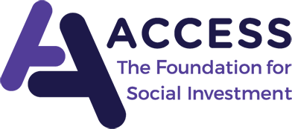
Enterprise Support Framework Tender
December 2020

FORM OF APPLICATION

To be returned by 17:00 on Friday 15 January 2021 to
applications@access-si.org.uk

Name of Accountant
Address and Contact Details
Qualifications Held
Employing Organisation
(if applicable)
Core region  please select one region – this should be the region you have as your working base | East of England  East Midlands  London/South East  North East  North West  South West  West Midlands  Yorkshire & Humber |  | Other regions coverable  Please delete as appropriate, stating only those regions you would expect to accept referrals into and be able to travel FULLY within |  | East of England  East Midlands  London/South East  North East  North West  South West  West Midlands  Yorkshire & Humber
Price (£ per day INC VAT) to be charged for ALL work in 2021 (a nominal inflationary adjustment may be agreed in subsequent years)
Basis for additional charging of expenses

We would propose meeting reasonable travel expenses only, as a matter of course. If this would be an issue for you, please comment here. This will not affect the scoring of price but may be relevant to how we construct a framework offering national coverage
References

Please provide the names and contact details for TWO organisations we could approach regarding your specific experience relating to this tender
Statement of Understanding and Experience in relation to the schedule of work. Please include real examples.
Expand as required, max 400 words for this section

please also attach a CV for the accountant (not included in word count)

